PASSPORT AUTOMATION SYSTEM

Aim
To design and model a Passport Automation System using Object-Oriented Analysis and Design (OAAD) that automates passport application, verification, approval, and issuance processes efficiently, securely, and transparently.

Procedure
The Passport Automation System replaces the manual passport issuing process with an online system. Applicants can apply online, upload documents, schedule appointments, and track application status. Authorities verify documents, conduct police verification, approve or reject applications, and issue passports digitally and physically.

Core Objects
- Applicant
- Application
- Document
- Payment
- Appointment
- Verification
- Passport

UML Diagrams Output

Use Case Diagram

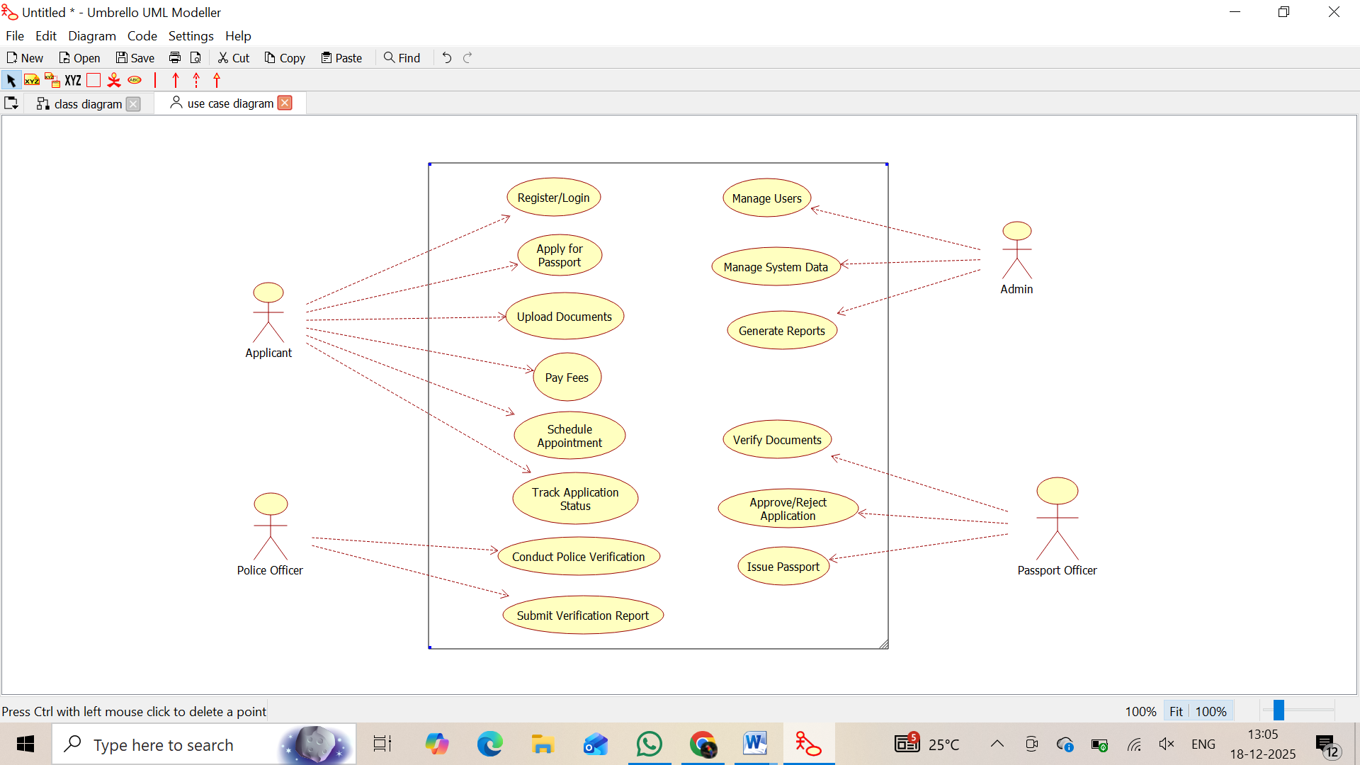
Class Diagram

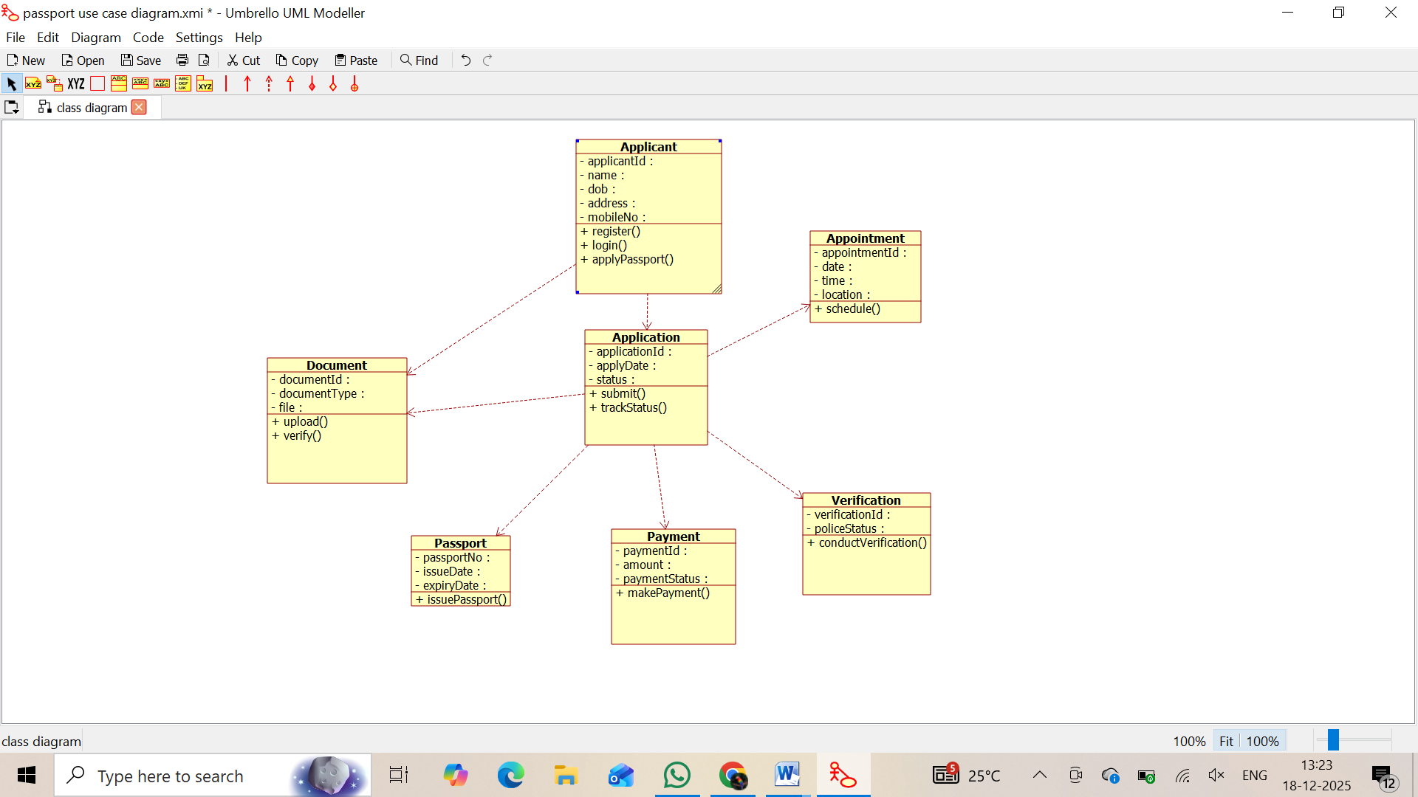

Sequence Diagram

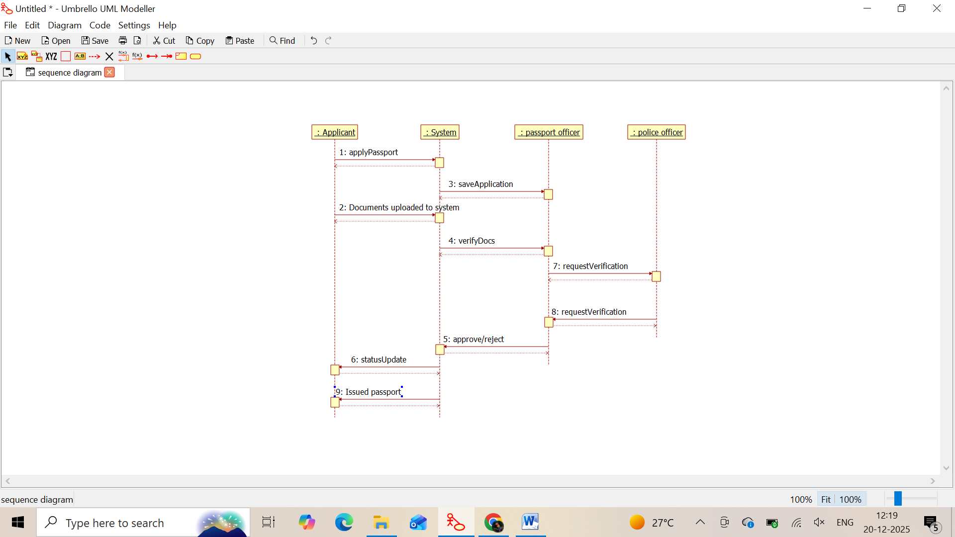

Activity Diagram
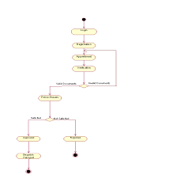

State Chart Diagram

